Maven – IS a project Management Tool

It will help to

* Build the project (Converting source code to byte code .java 🡪 .class)
* Test the project (Execute all the Unit Test code)
* Package the project ( Creating a Single jar/war/ear file – Compress all the files and create a single file)
* Generate code (Automatically create a output folder in the name of target and generate build files)
* Clean the project ( It deletes all the contents of target folder)
* Managing the project dependencies (Downloading all the jars and adding it to the build path)

There are two ways to use maven

1. Using command prompt (stand-alone maven)
2. Using plugins from the IDE (It’s available as a plugin in Eclipse, IntelliJ, NetBeans etc.,)

Official site - <https://maven.apache.org/>

Download URL - <https://maven.apache.org/download.cgi>

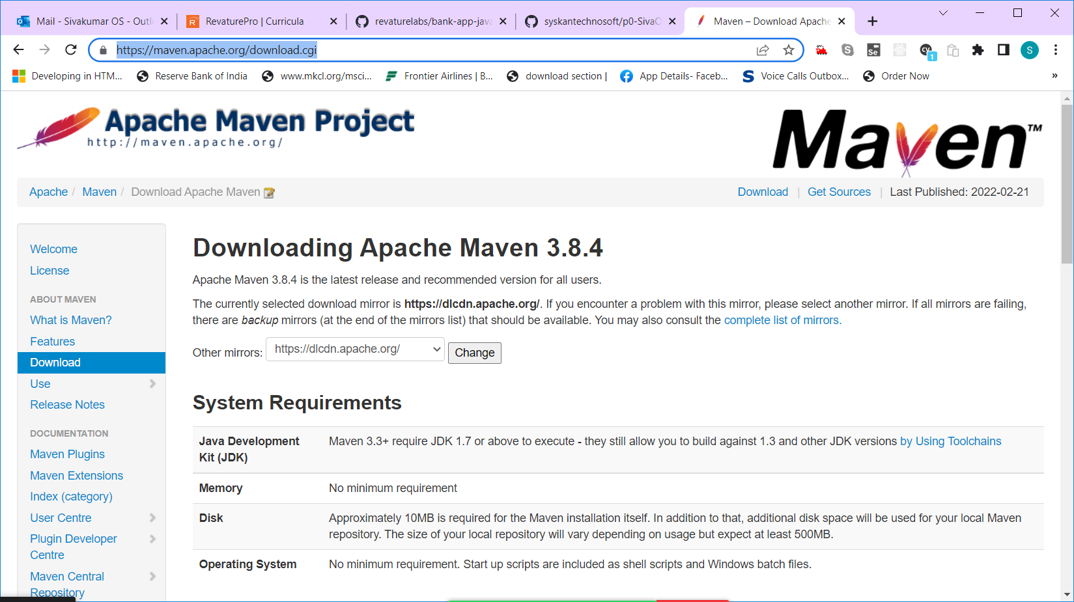

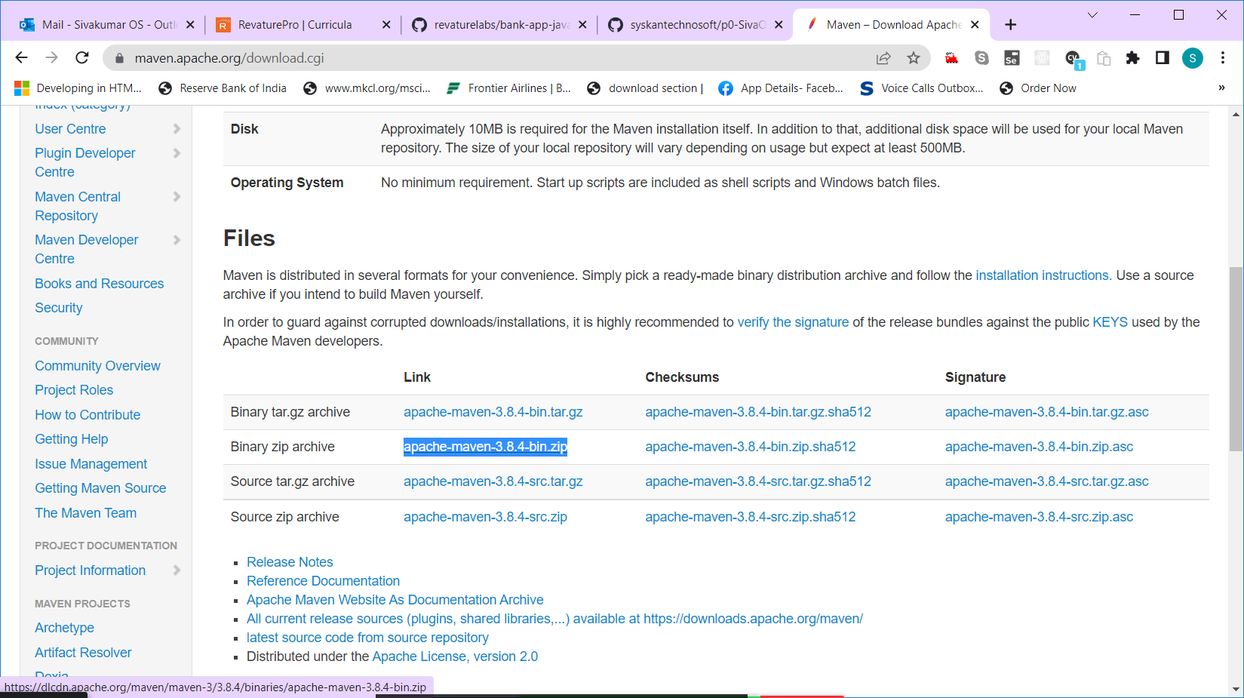

Download the “apache-maven-3.8.4-bin.zip” file from the above link.

Checking Maven installation

1. Open the command prompt

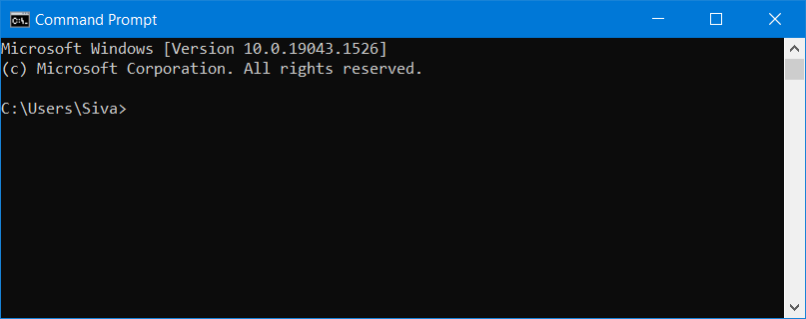

1. Mvn (enter)

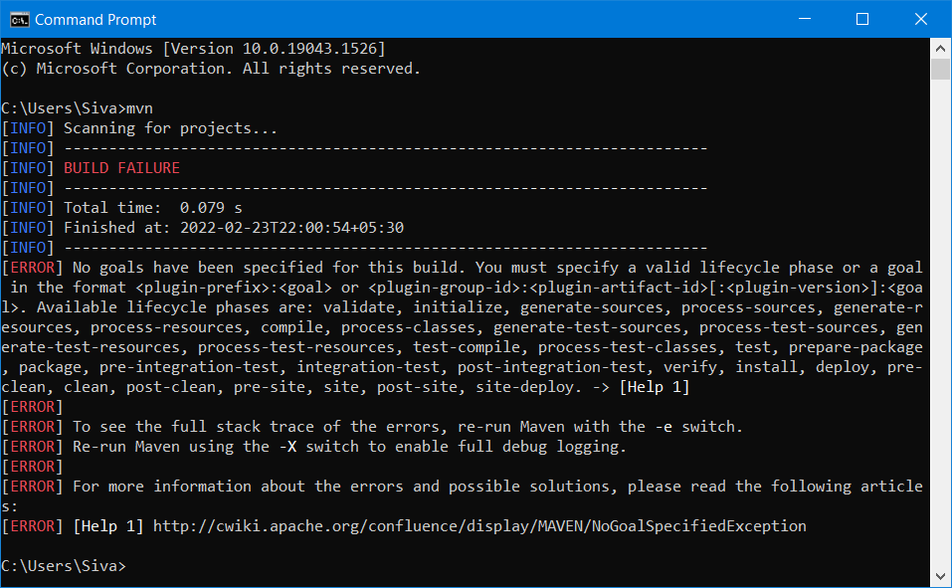

1. If you get error message “mvn is not recognized as an internal command/file” download the maven file mentioned above and extract it in c drive.

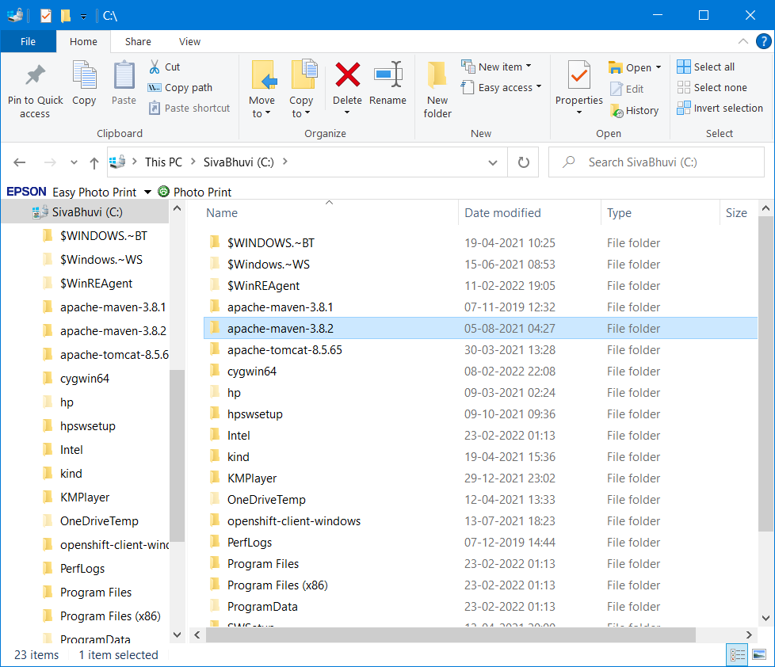

Step 4:

Maven expects two environment variables a) JAVA_HOME b) M2_HOME (maven home)

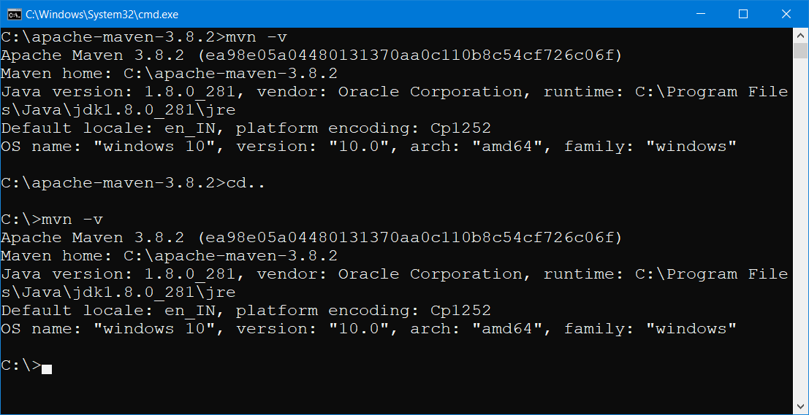

Step 5 : Adding maven to path

Open Environment Variable

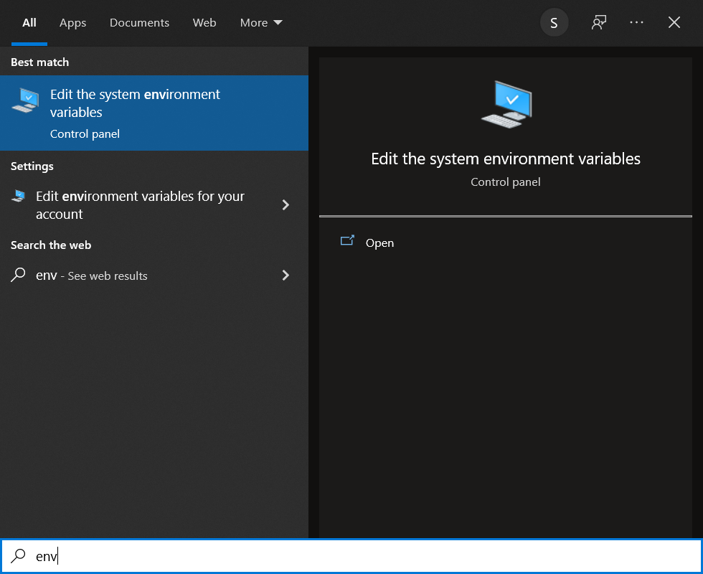

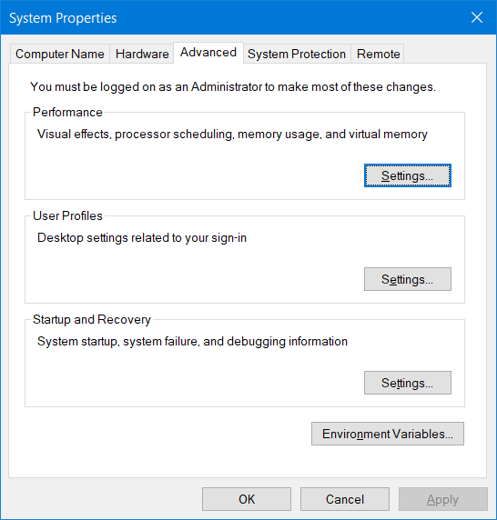

Click on “Environment variables..” button

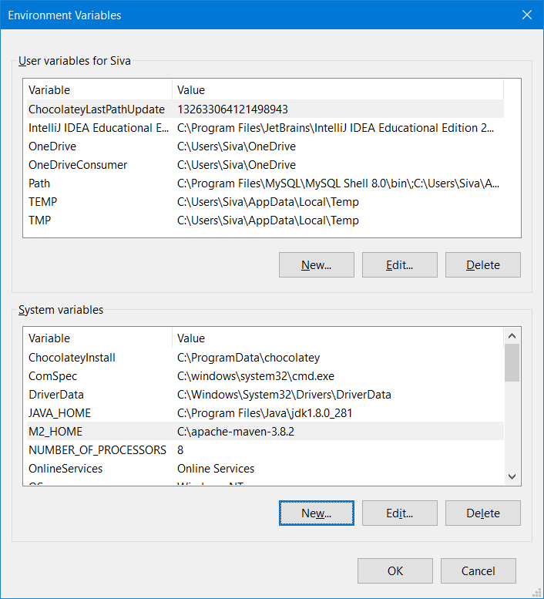

Click on “New” button and type M2_HOME and paste the maven folder path as shown below

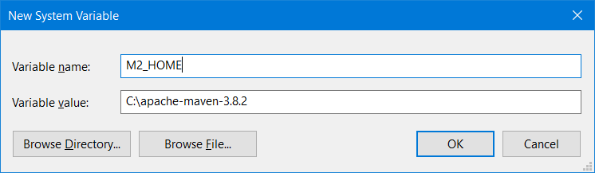

Click on Ok.

Select “path” environment variable and click on edit button.

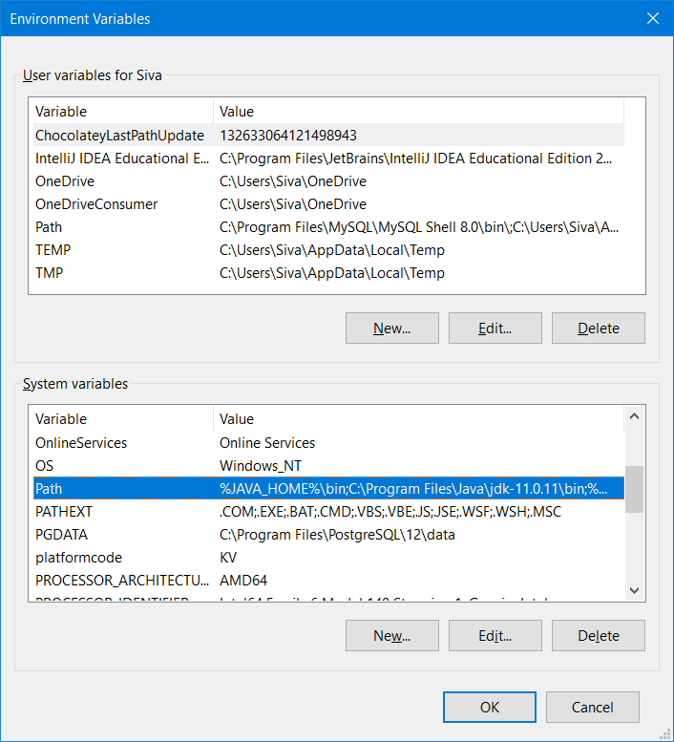

Click on “new” button to add a entry “%M2_HOME%\bin”

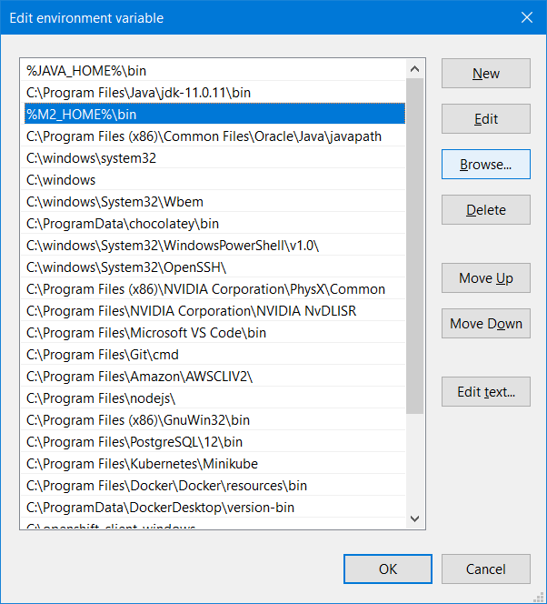

Click “Ok” three times.

Open a new command prompt and type mvn -v

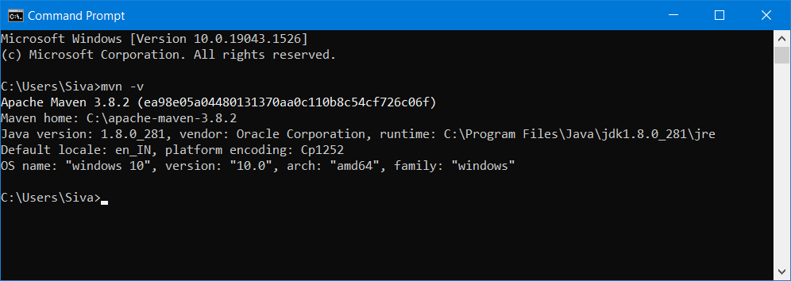

Important Maven commands

1. mvn -clean
2. mvn -install
3. mvn -package
4. mvn -test
5. mvn -build
6. mvn -generate – To create a new maven project

Maven is project Management Tool.

Any java project can be converted in to maven project in eclipse. Select the project, right click 🡪 configure 🡪 convert to Maven project

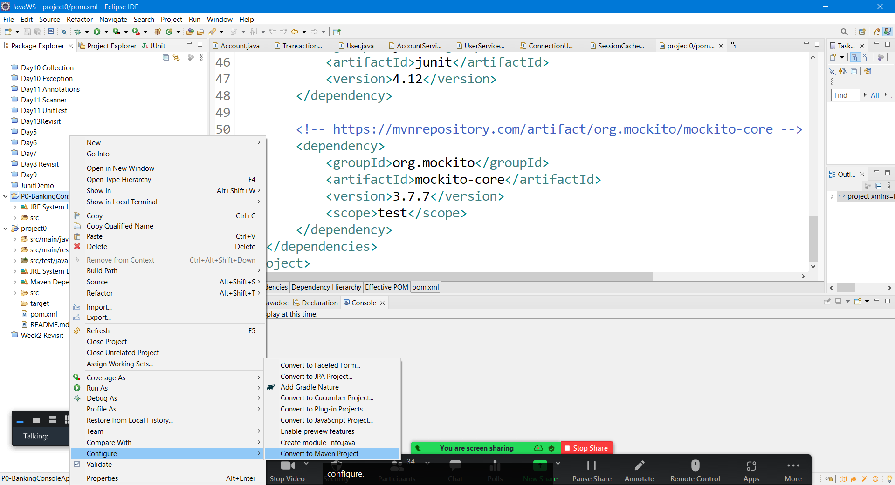

Types of Maven Repos –

* Local Repository - .m2 (folder) – Maven Local repository - C:\Users\Siva\.m2\repository
* Remote Repository – cloudspace – where all the jar files can be download to the local repo (<https://mvnrepository.com/> , <https://repo.maven.apache.org/maven2/> , <https://search.maven.org/> )

The back bone of a maven project is pom.xml file

POM – Project Object Model

Every maven project will have two mandatory properties

1. groupId (reverse of the company url) [mandatory]
2. artifactId (name of the project) [mandatory]
3. version [optional SNAPSHOT-0.0.1]
4. description [optional]
5. name [optional]

How to create a maven project

1. Using maven command (mvn archetype:generate -DgroupId=com.revature -DartifactId=MyMaven -DarchetypeArtifactId=maven-archetype-quickstart -DinteractiveMode=false)
2. Using Eclipse or any other IDE

Method 1 :

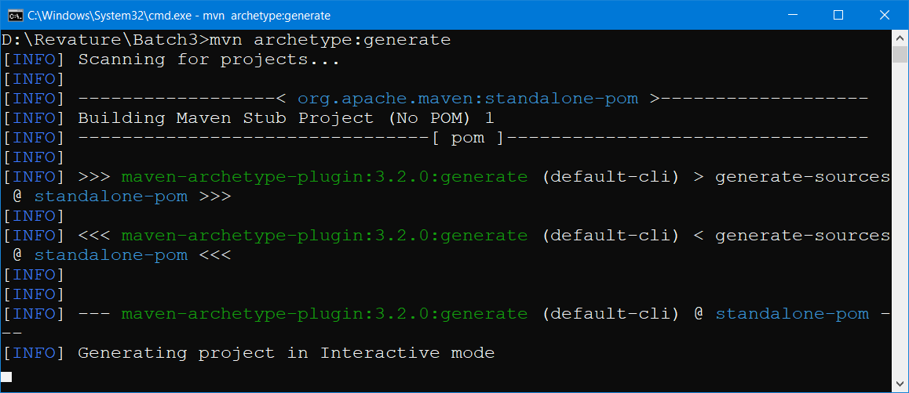

Two modes of Creating maven project in command prompt

1. Interactive mode – mvn archetype:generate (it will ask you questions & based on the user input, maven project will be created)
2. Batch mode -- mvn archetype:generate -DgroupId=com.revature -DartifactId=MyMaven -DarchetypeArtifactId=maven-archetype-quickstart -DinteractiveMode=false ( It will create the project)

Method 2: Using Eclipse

File-🡪 New 🡪 Other

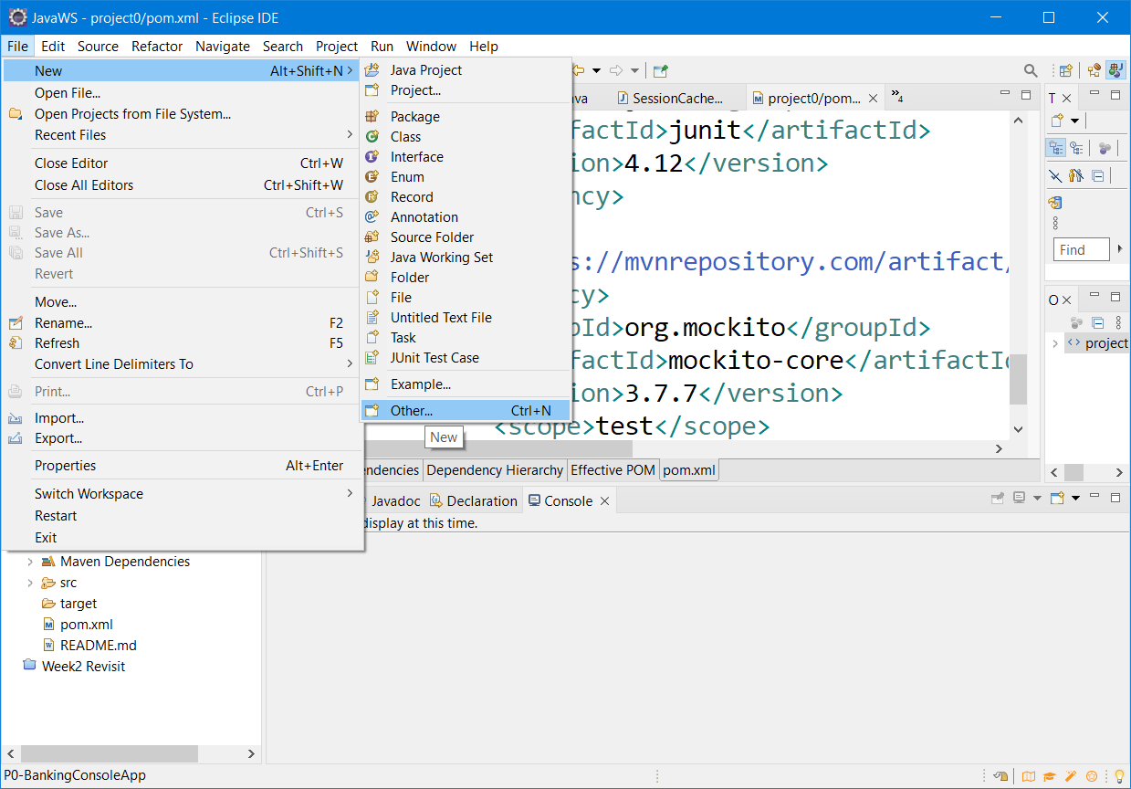

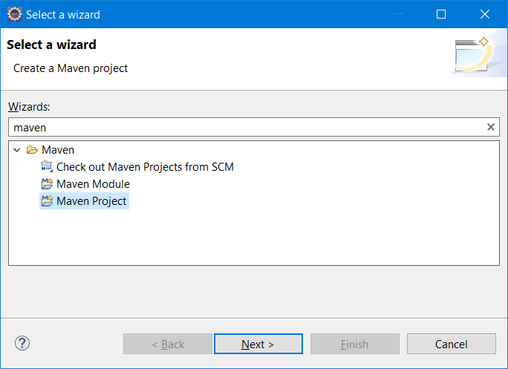

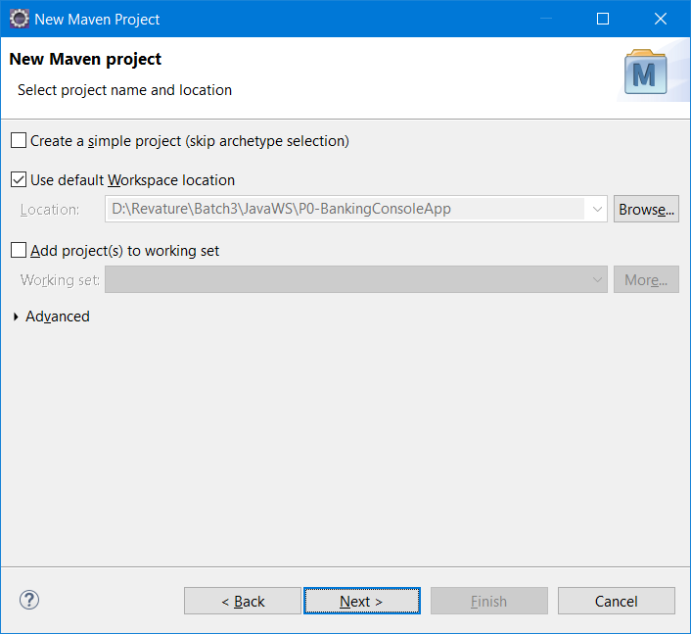

Selecting the “Create simple project (skip archetype selection) will show the below screen

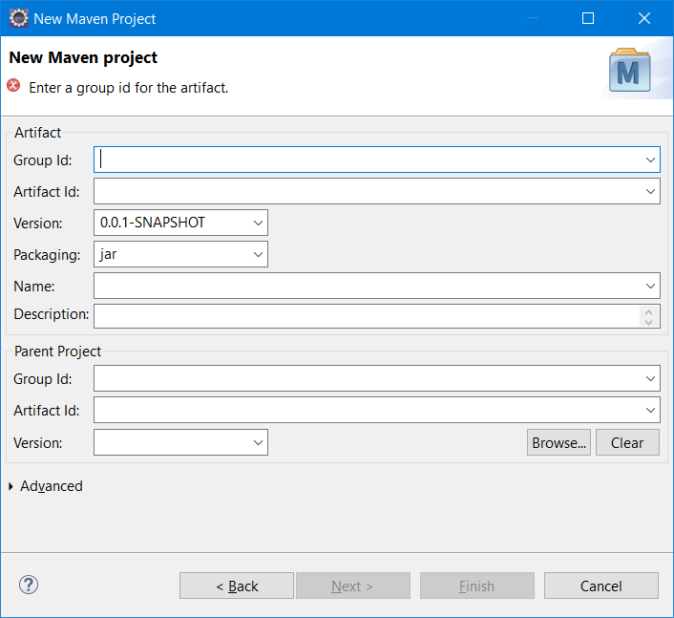

Without selecting the checkbox, the following screen will appear to choose the project archetype. Make sure to change the catalog to “internal”

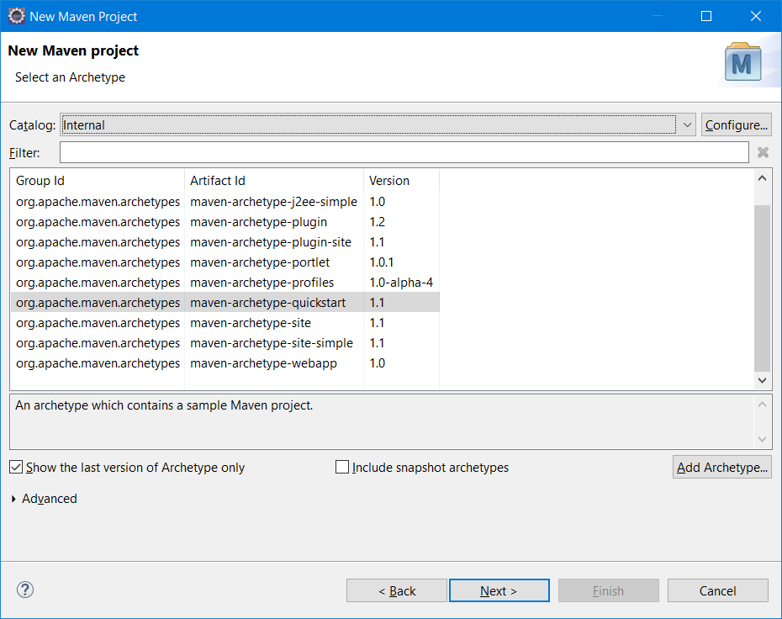

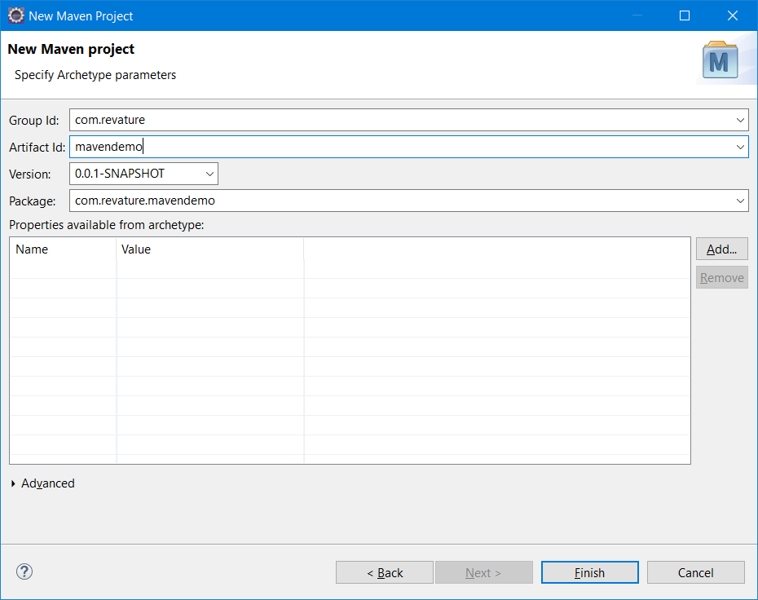

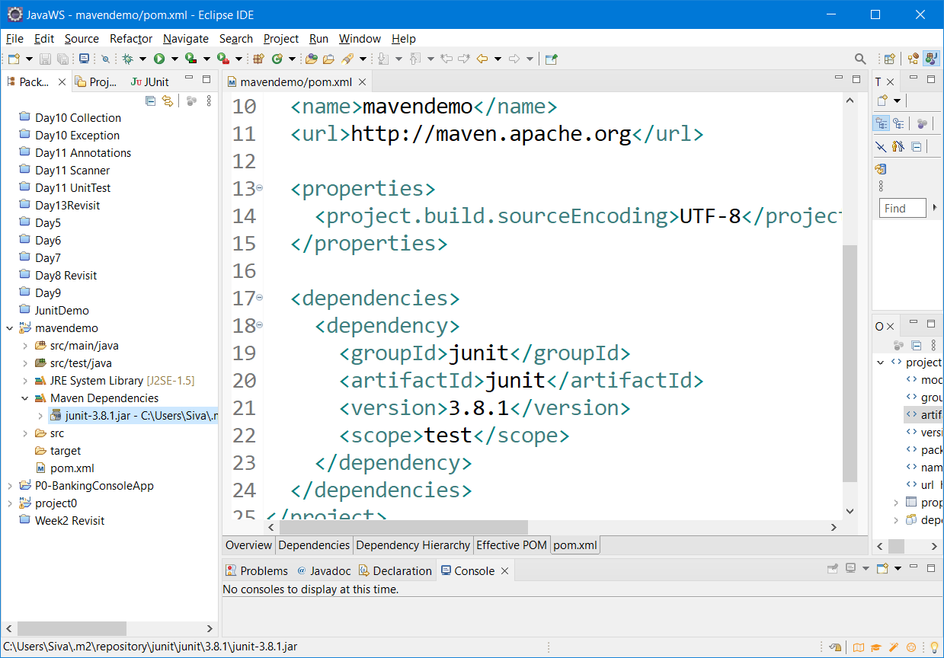

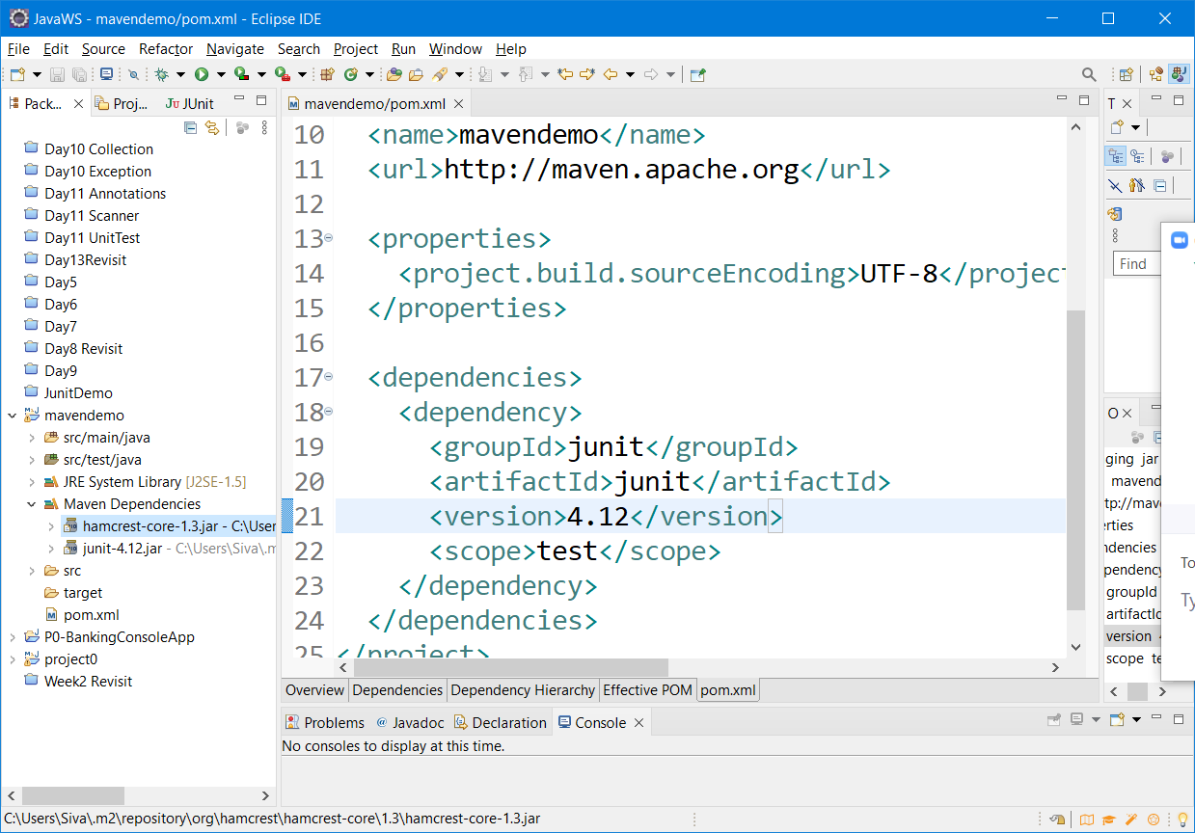

Maven – Is a project management Tool

* Back bone of maven project is pom.xml (Project Object Model)
* Maven will help to build, test, package, deploy, manage dependencies of project
* Created by command or by using ide plugin
* Using command – interactive mode, -batch mode
* Downloading and installing maven, adding M2_HOME & updating path
* Local repo .m2, remote repo (mvnrepository.com, search.maven.org )
* Two important properties of pom groupId, artifactId

Maven LifeCycle

1. Validate => project is correct and all necessary information is available
2. Compile => compiles project source code (build process)
3. Test => tests all compiled code
4. Package => packages all compiled code to WAR/JAR file
5. Integration => performs all integration tests on WAR/JAR
6. Verify => runs checks on the results of integration tests
7. Install => installs WAR/JAR to local repository
8. Deploy => copies final WAR/JAR to the remote repository

Stack & Heap Area – These are memory locations in JVM

Stack – where we store statements, method code

Heap – This is the place where objects gets created.

Garbage collection – In java, the process of reclaiming memory of unused/unreferenced objects

This can be forced explicitly by System.gc() 🡪 Invoke Garbage collector

Finalize() – Is a method that gets called automatically when garbage collection is performed by the JVM.

Thred (Thread is a lightweight process)

Process is a heavy weight thread

Ways of Creating Thread

1. Using the Thread class
2. Using the Runnable interface

Thread Life -cycle methods

Start(), run(), sleep(), wait(), yield(),

Various state of the Threads

1. NEW
2. RUNNABLE
3. RUNNING
4. Blocked/Interupted
5. RUNNING
6. TERMINATE

Agile –

Three documents

1. Product backlog
2. Sprint backlog
3. Burndown chart

Sprint, Epic, User Stories

Epic – High level statement – Create a login screen , Add upi payment functionality, enables OTP

User Stories – Epic will be broken into multiple user stories (As a ___, I want to ____, so that I can perform ____)

TDD – Test Driven Development.